

**Proposal and Quotation for Meta Verified WhatsApp Bulk Messages with Brand Name**

https://www.veloxn.com

**Introduction -**

Thank You for showing interest in Meta Verified WhatsApp Bulk Messages with Brand Name with Veloxn Private Limited

**Service Cost -**

The table below details the cost associated with this service.

|  |  |  |  |  |
| --- | --- | --- | --- | --- |
| **Name** | **Price** | **Qty.** | Validity | **Final Subtotal** |
| Proposal and Quotation for Meta Verified Blue Tick for Lifetime | 11,000 |  | - | 11,000 |
|  |  |  |  |  |
| **Sub Total** |  |  |  | ₹11,000 |
| **GST (18%)** |  |  |  | ₹1,980 |
| **TOTAL Including GST** |  |  |  | **₹12,980** |

Payment required is **₹12,980**

**Note\*** - Offer Valid for 2 days only

**Bank Details**:

**VELOXN PRIVATE LIMITED**

AC Number – 259958439076

IFSC Code – INDB0000702

Bank Name – Indusind Bank

UPI ID - veloxnservices@okicici

QR Code – 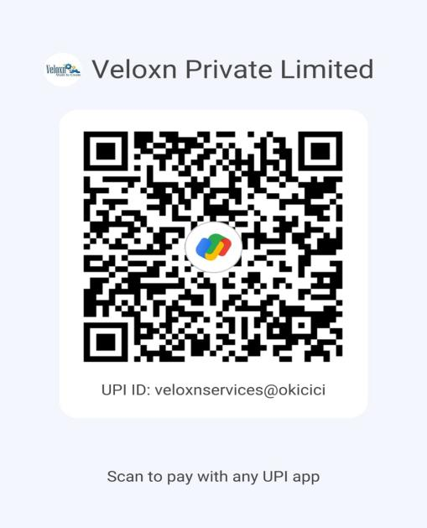

**COMPANY:**

Veloxn Private Limited

Iconic Tower C, Corenthum, Sector-62, Noida, UP - 201301, India www.veloxn.com

sales@veloxn.com

91-7292001010

GST - 06AAICV7138B1ZE